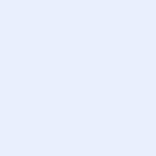
HEINRICH KRISTOFER M. LEYVA
3085 Apple Street, United Paranaque Subdivision 1,
Paranaque City
+639772175528
leyvahk@gmail.com

OBJECTIVE
To join an organization where I can use my skills in personnel administration and attain a high level of performance in personnel recruitment and training.

EDUCATION

2018 de la salle university
Bachelor of Science in Mechanical Engineering with specialization in Mechatronics

2012-2018 COLEGIO SAN AGUSTIN - MAKATI
High School Diploma, March 2018. STEM Graduate in Colegio San Agustin – Makati Senior High School

WORK EXPERIENCE

2017-2018

Worked as a driver for my mother during summer to attend to business needs.

August- September 2018

Working Student; Print Copy Ventures

PERSONAL BACKGROUND

Born on May 8, 2000 in Quezon City, Philippines. Can understand and speak in Filipino and English. Knowledgable in Microsoft Office Applications, video editing and online applications in designing posters, brochure, etc. Interests: Engineering, Technology, Cars, Computers.

Simple and eager to get things done on time, can tolerate people with varying personalities , can adapt to different working conditions, creative and business oriented.

REFERENCES

Name: Leticia M. Leyva
Relationship: Mother
Contact #; 09178202909

Name: Raoul Gerard G. Leyva
Relationship: Father
Contact #: 09178525650

